 

# Placement Empowerment Program Cloud Computing and DevOps Centre

Set Up a Virtual Machine in the Cloud:

Create a free-tier AWS, Azure, or GCP account. Launch a virtual machine and SSH into it.

Name: Manashaa.U Department:CSE



Introduction

In this proof of concept (POC), we will explore how to launch virtual machine in the cloud.here I have used azure portal to create my virtual machine

Step1:

Go to azure portal and click on “virtual machine”.

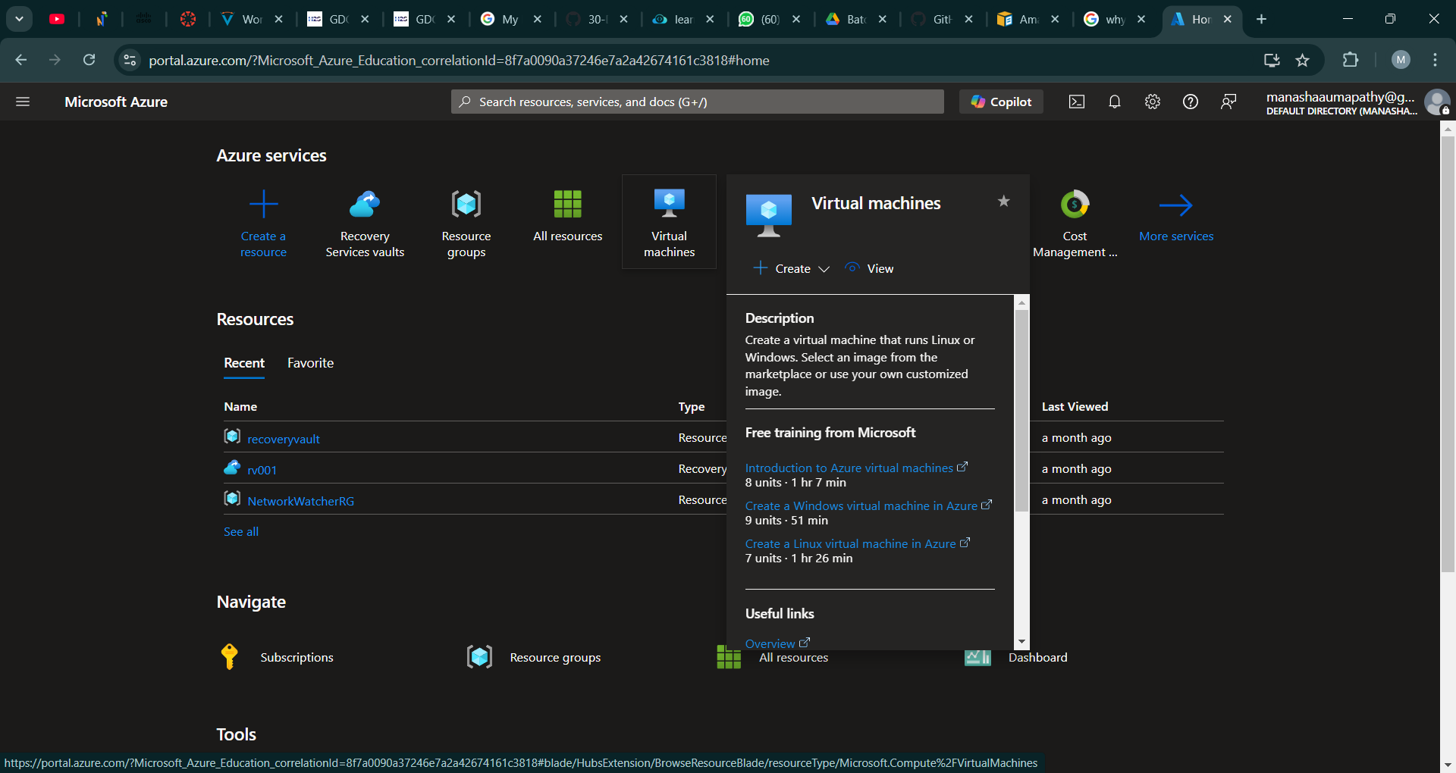

Step 2 :

Enter the essential details such as subscription, resource group ,virtual machine name ,region ,availability options

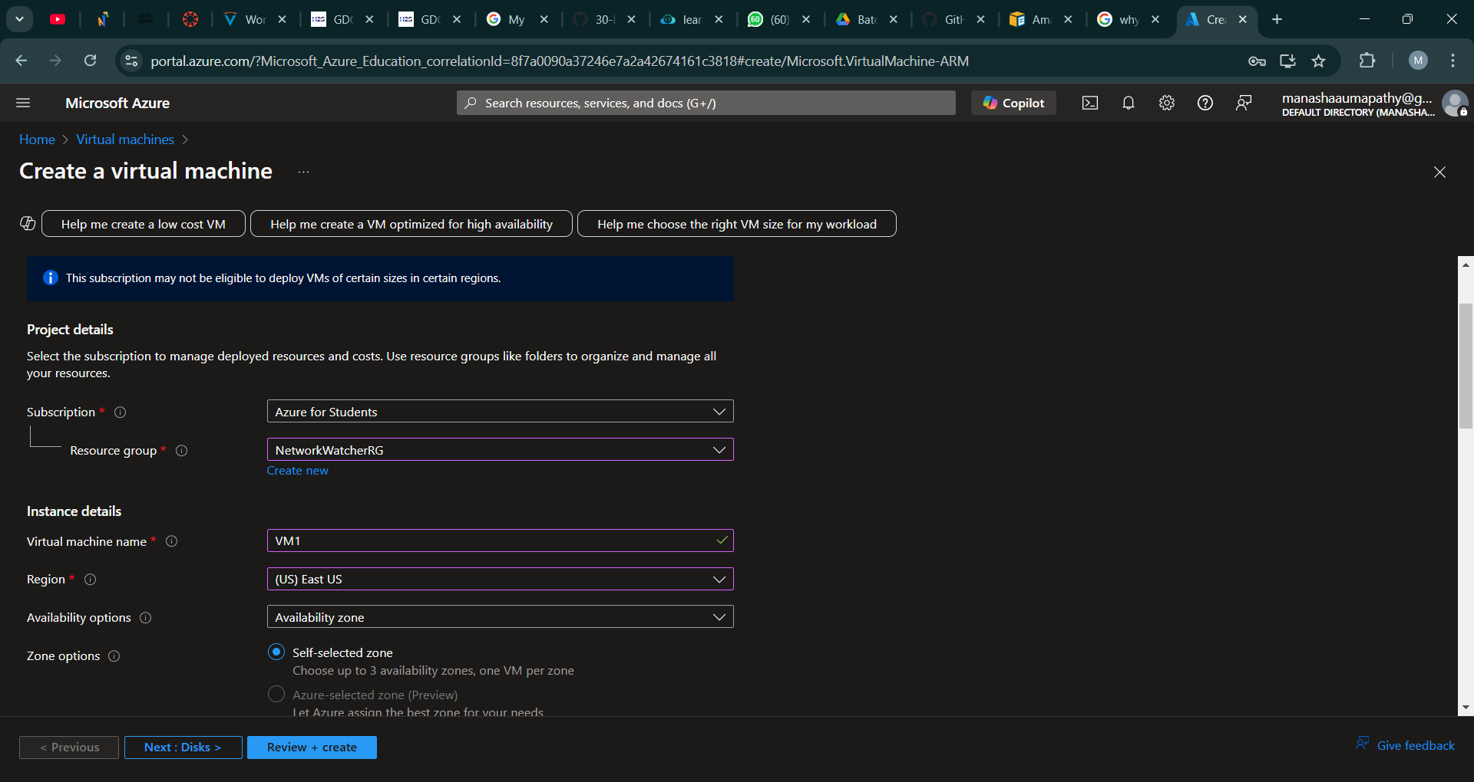

Step 3 :

Once the validation has passed , click on “Create”.

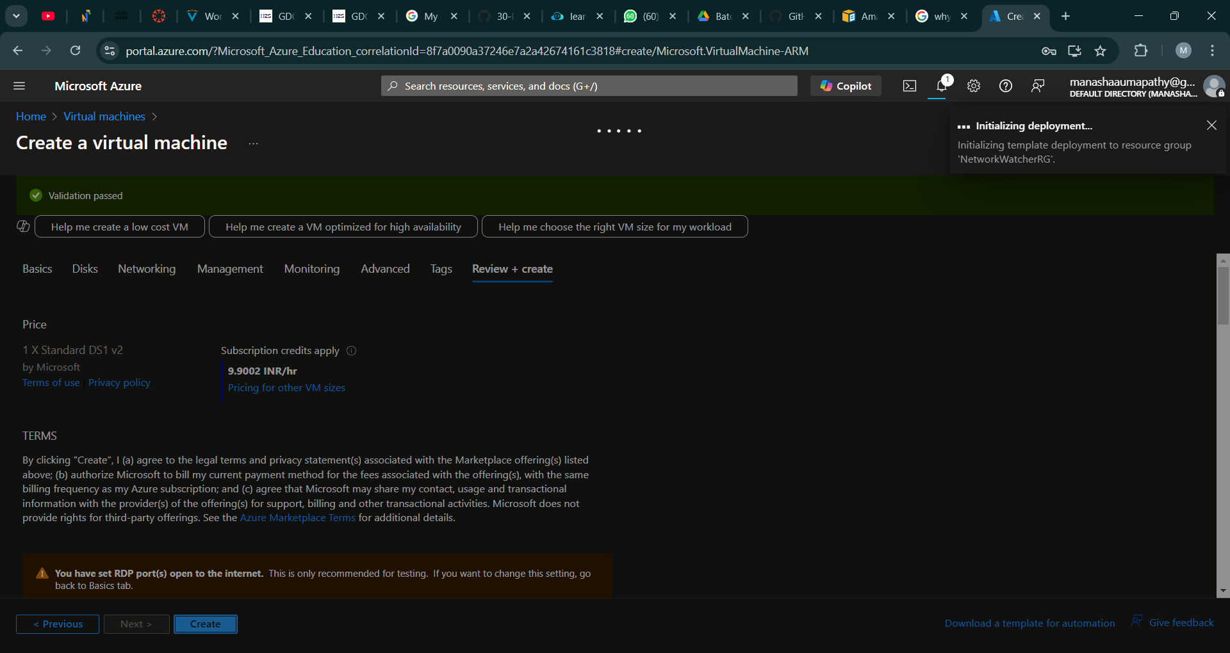

Step 4 :

Wait until the deployment is over

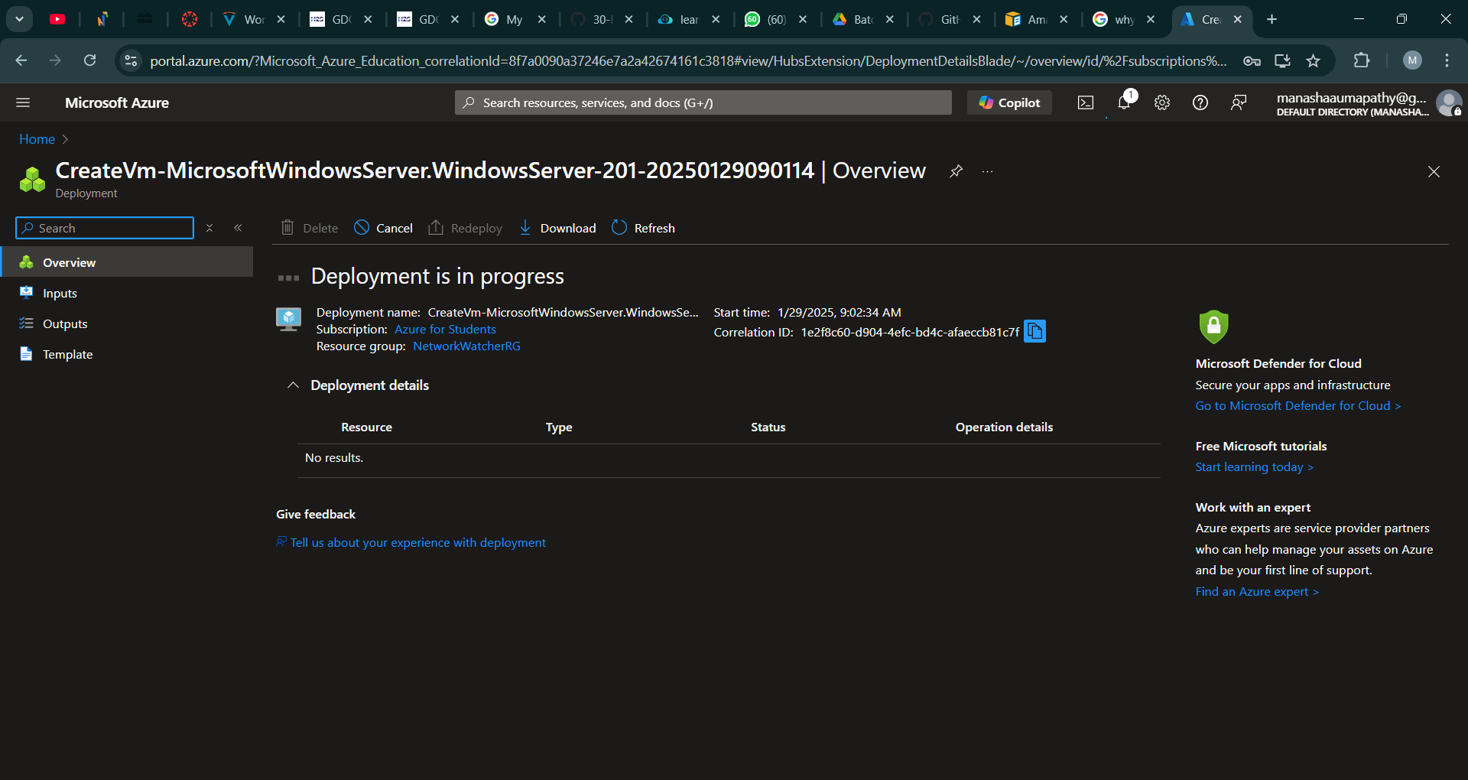

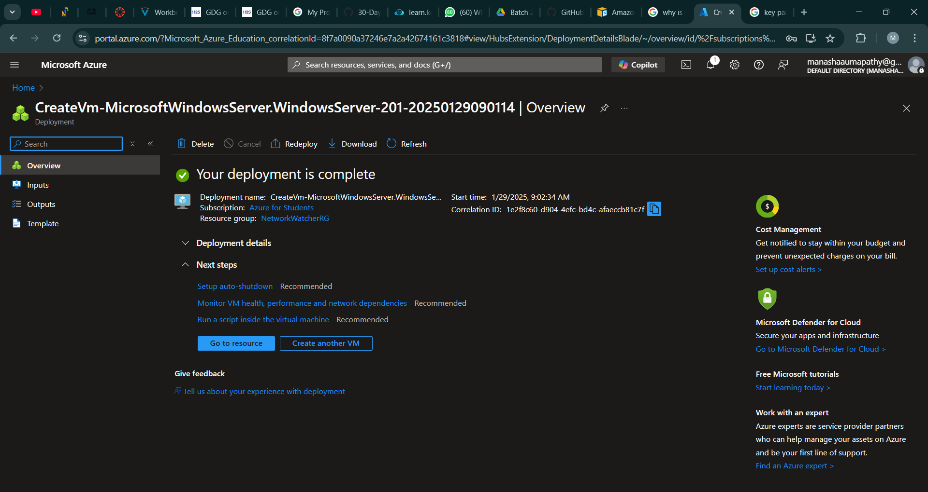

Step 5:

Your virtual machine is created.

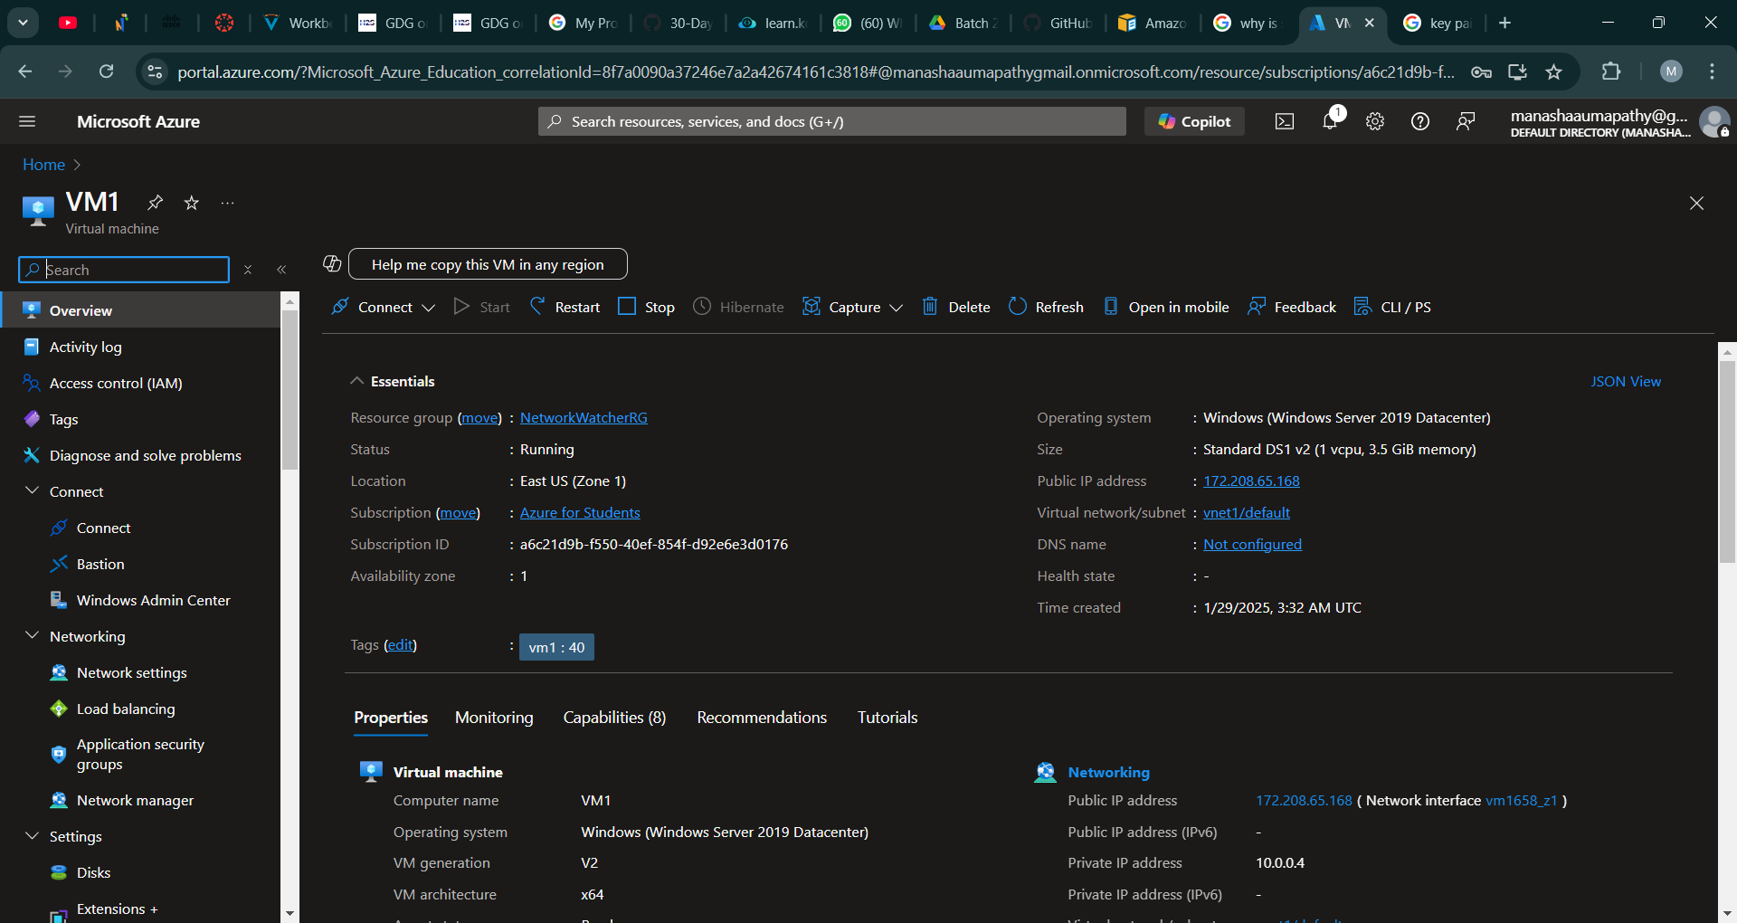

OUTCOME:

-SUCCESSFULLY CREATED A VIRTUAL MACHINE